2015 Korean Civil Service Pension Reform

August, 2015

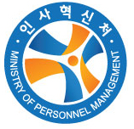 | Ministry of Personnel Management

< Summing-up >
"Pension Reform for the Future Generations
- pay more, receive less with 5-years pension freezing via social consensus -
❍ The Korean government completed the reform of the Civil Service Pension (CSP) on 29 May 2015, in order to lesson it's financial deficit and enhance an equity with the National Pension (NP).
ⅰ) financial deficit : ^{’01}59.9 → ^{’10}1,307.2 → ^{’14}2,485.4 (in billion Korean won)ⅱ) money's worth ratio (benefit/contribution) : CSP 2.1 v.s. NP 1.5

❍ Upon the reform, civil servants pay 28.5 percent more and receive 10.5 percent less. Pension are to be frozen for 5 years.

❍ While previous prevision reforms were typically government-driven, the 2015 reform was done via social consensus with the participation of a wide range of stake-holders.

❍ Core Features of the New Pension System are:
ⅰ) pension are to be frozen for next five years (’16～’20)
ⅱ) to pay contributions (employee+gov't) more (14%→ 18%) and receive pension less (1.9%→1.7%)ⅲ) to raise the normal retirement age (60→65)ⅳ) to strengthen earnings test and introduce income redistribution

❍ Major Achievements of the 2015 Pension Reform include:
ⅰ) (Financial Perspective) For next 70 years, financial deficit is estimated to decrease by 497 billion won and the government burden to decrease by 333 trillion won.
 | accumulated deficits  (in trillion won) |  |  | accumulated government burden  (in trillion won)
 | before | after | reduction | before | after | reduction
70 years  (’16～’85) | 1,238 | 741 | 497  (-40%) | 1,987 | 1,654 | 333  (-17%)
ⅱ) (Equity Perspective) MWR (ratio of benefit to contribution) of the CSPS and the NPS are to be the same (CSPS 1.48%→ NPS 1.5%).
Ⅰ. Introduction

○ There are various structures of civil service pension related with National Pension such as i) an entirely separated system with National Pension, ⅱ) a fully (or partially) integrated with top-up system and iii) a fully integrated system. The structure of the Korean Civil Service System belongs to the first type.
<Types of Civil Service Pension around the World>
entirely separate  system | fully (Partially) integrated  with top-up system | fully integrated  system
France, Germany.  Korea | Canada, Japan. Spain  Sweden, UK, USA | Chile, Czech Republic, Hungary

○ Since the early 1990s, almost all industrialized nations have undertaken civil service pension reform, faced by serious demographic and financial pressures.

○ Confronted by the same challenges, the Korean government have also reformed the civil service system in a consistent basis. The past reforms took place at 1995, 2000, 2009 and 2015.
< Past Reforms of the Korean Civil Service Pension System >
 | features
1995 reform | •increasing contribution rates (3.6% → 4.9%)  •introducing the retirement age (age of 60 only to the newly hired)
2000 reform | •increasing contribution ratse (4.9% → 5.5%)  •raising the retirement age of the hired before 1996 incrementally (will be set 50 at 2001 and raised 60 until 2021)  •expending period of pension calculation (final wage → final 3 years' average wage)
2009 reform | •increasing contribution rates (5.5% → 7%) / accrual rates (2.1% → 1.9%)  •raising the retirement age (65 only to the newly hired)
○ However, the 2015 pension reform is the most recent and the strongest in cost reduction through social consensus mechanism with the participation of a wide rage of stake-holders.
Ⅱ. The Need for Reform

○ The Civil Service Pension, as the first public pension in Korea, was set up in 1960, primarily as a personnel vehicle to recruit, retain, and motivate a competitive work force. However, as the system had been matured from the mid-1990s, it began to run into both of financial and equity problems.

- (Financial issue) Mainly due to a generous contribution-benefit structure and a rapid increase of the pensioners from the growing life expectancy, the subsidies by the government budget for the CSP rosed 41 times over past 13 years (⁰¹59.9 → ¹⁰1,307.2 → ¹⁴2,485.4, in billion won)
【Major Factors for the System's Financial Instability】
【generous contribution-benefit structure】In return for low wage and retirement re-numeration, the level of pension benefits in the system has been relatively high, compared to contribution
‣ benefits (33 years' service) : ^{’60}46% → ^{’67}65% → ^{’81}76% → ^{’10}62.7%‣ contributions (combined) : ^{’60}3% → ^{’70}7.2% → ^{’96}8.4% → ^{’01}11% → ^{’10}14%

【ageing demographies】Due to the advanced medical technologies, life expectancy has been expanded and thus pensioners rapidly increased.
‣ life expectancy : ^{’60}52 → ^{’81}66 → ^{’05}77 → ^{’13}82 (years old)‣ dependency ratio (pensioners/contributors) : ^{’82}0.6% → ^{’90}3.0% → ^{’14}36.6% - the number of pensioners : ^{’82}3.7 → ^{’90}25 → ^{’14년}396 (in thousands) - the number of contributors : ^{’82}667 → ^{’90}843 → ^{’14}1,081 (in thousands)

- (Pension Equity issue) The Civil Service System has been criticized for the pension benefit disparity and comparability issue between civil servants and private sector employees.
 | Civil Service Pension | National Pension
money's worth ratio  (benefits/contribution) | 2.08 times | 1.5 times

○ Consequently, serious concerns were being voiced over the need to improve the system’s financial soundness and resolve pension equity problem.
Ⅲ. Pension Reform Process

○ On February 14 2014, President Park expressed a strong intension for the Civil Service Pension reform.

○ In the early 2014, the government commissioned a research institute, Korea Development Institute (KDI), to draft reform proposals and the institute presented its proposals to the government in the mid 2014.

○ On October 28 2014, the ruling party Saenuri Party (SP) submitted a reform bill in the name of all members.
- However, civil service unions and the main opposition New Politics Alliance for Democracy (NPAD) strongly opposed the reform bill.

○ In December 29 2014, in order to seek a social consensus on the pension reform, the National Assembly set up Special National Assembly Committee and Grand Compromise Committee which comprised rival parties' congressmen, government officials, civil service unions and experts.
- After having five dozens of conferences over 6 months, in the late May 2015, a grand consensus on the pension reform was reached.

○ In May 29, 2014, the final reform bill was submitted to the National Assembly and the bill passed 233-0 with 13 abstentions.

○ In June 22, 2015, the government made the law public and the law will be implemented from January 1, 2016.

○ In overall, both of the government and the National Assembly and opened a way to resolve various reform problems through social compromise and consensus.

< Important Developments of the 2015 Pension Reform >
date | events
February 25, 2014 | President Park expressed a strong intension for the Civil Service Pension reform in her annual announcement
January~June, 2014 | Korea Development Institute (KDI) carried out a reform project
October 17, 2014 | the government (the Ministry of Personnel Management) announced her reform proposal
October 28, 2014 | the ruling Saenuri Party(SP) submitted a Civil Service Pension reform bill
December 29, 2014 | the National Assembly set up the Special Committee and the Grand Compromise Committee
January~May, 2014 | the Special Committee in the National Assembly, coupled with the Grand Compromise Committee, launched reform discussion  * 59 times of committee conferences and public hearings (90 times when unofficial meetings are included)
May 2, 2015 | the National Assembly agreed on the reform bill in a wider context
May 29, 2015 | the National Assembly passed the Civil Service Pension Reform bill
June 22, 2015 | the Government made the law public
January 1, 2016 | the Reform bill will be implemented.
Ⅳ. The New Pension System

1. Main Features

<Benefits and Contribution Structure of the CSP after the 2015 Reform>
 |  |  | before the reform |  |  | after the reform
income base |  |  | gross wage (no change)
ceiling of contribution and benefits |  |  | 1.8 times of average wage for all members |  |  | 1.6 times of average wage for all members
benefit formula of retirement benefits  (accrual rate per year) |  |  | 1.9%× n  * n : contributory year |  |  | 1.7%× n  * n : contributory year
maximum years of contribution |  |  | 33 years |  |  | 36 years
contribution rate |  | employee | 7% |  |  | 9.0% (5 years' transition)
 |  | employer  (gov't) | 7% |  |  | 9.0% (5 years' transition)
pension base |  |  | career average gross wage
normal retirement age |  |  | the newly |  | 60 | 65 (11 years' transition)
 |  |  | the current |  | 65 | 65 (11 years' transition)
cost-of-living increases |  |  | CPI (no change)
pension freezing |  |  | no |  |  | 5 years (2016〜2020)
minimum service years |  |  | 20 |  |  | 10
survivors’ pension |  |  | the newly | 70% |  | 60%
 |  |  | the current | 60% |  | 60%
non-job related disability pension |  |  | no |  |  | yes
income redistribution |  |  | no |  |  | yes
pension splitting |  |  | no |  |  | yes
earnings test | reference earning |  | average salary |  |  | average pension
earnings test | coverage |  | real estate income excluded |  |  | real estate income included
2. Major Achievements

□ The benefit structure was internally decomposed into 3 items by function such as National Pension equilibrant, Occupational Pension equilibrant and Self-saving equilibrant so that the benefic structure became transparent.
before the reform | ⇒ | after the reform
Retirement Allowance  (39% of RA for private sector employees) | ⇒ | Retirement Allowance (no change)
Civil Service Pension  (employee contribution : 7%)  (benefit : 1.9%)  *mixture of National Pension, Occupational Pension and self-saving | ⇒
 | ⇒ | Occupational Pension equivalent : 0.4% |  | employee  contribution : 9%  benefit : 1.7%
 | ⇒ | Self-saving(4.5%) equivalent : 0.3% |  | employee  contribution : 9%  benefit : 1.7%
 | ⇒ | National Pension(4.5%) equivalent : 1% |  | employee  contribution : 9%  benefit : 1.7%

□ Civil servants pay 29 percent more and receive 11 percent less. Consequently, MWR between the CSPS and the NPS are to be almost same and thus the equity with National Pension was enhanced.
 | CSPS after the reform | NPS | comparison
employee contribution | 7% → 9% | 4.5% | 2 times of NP
benefit | 1.9% → ^{’35}1.7% | ^{’28}1% | 1.7 times of NP
entitlement age | eventually 65 |  | the same
survivors pension | eventually 60 |  | the same

□ Pension are to be frozen for next 5 years (’16～’20) and payment conditions are strengthened so that the pensioners would share in the pains suffered.
 |  | before the reform | after the reform
full suspension |  | when re-hired | when re-hired, when employed under public corporate, when extended to elective civil servants
partial suspen-sion | reference | average salary(3,380 thousand won) | average pension(2,240 thousand won)
partial suspen-sion | coverage | real estate income excluded | real estate income included
indexation |  | CPI | CPI after 5 years' pension freezing

□ Pension redistribution was introduced to enhance an intra-generational equity between high-incomers and low-incomers.
Ⅴ. Financial and Equity Impacts of the 2015 Reform

□ (Lessening the future tax-payers' burden) Over the next 70 years (2016~2080) system's financial deficit is expected to decrease by some 497 trillion won with 40 percent of financial reduction. Consequently, the government's future burden would decrease by 333 trillion won.
The financial shortage will be within 14 percent of personnel expense
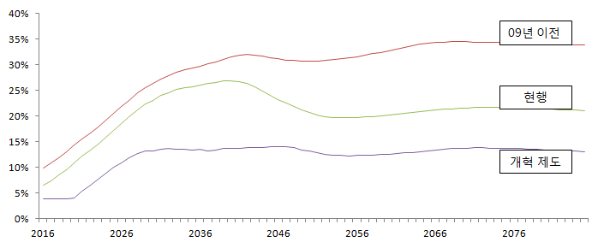

The gross government expenditure will be within 30 percent of personnel expense
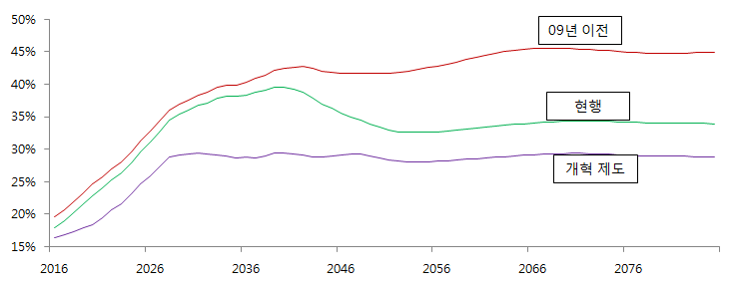

□ (Enhancing pension equity with National Pension) Civil servants pay 29 percent more (7% → 9%), receive 11 percent less (1.9% → 1.7%) and receive later (60yrs → 65yrs) so that the cost-benefit structures of the CSPS and the NPS become almost the same.
< Comparison of the Pension MWRs between the CSPS and the NPS>
(when newly hired in 2016 with 30 years service)
category | CSPS |  | NPS
category | before the reform | after the reform | NPS
pension MWR | 2.08 | 1.48 | 1.5
Note: MWR is defined as the ratio of present value of expected pension benefits to the present value of expected contribution

□ (Enhancing inter and intra generational equity among civil servants) Pension redistribution is introduced to enhance an intra-generational equity between high incomer and low incomer. Pension are to be frozen for next five years (’16～’20) and earning tests are strengthened so that the pensioners would share in the pains suffered by active civil servants.

□ (Reform policy making process via social compromise) While previous reforms were typically government-driven, the 2015 reform was done via social consensus with the participation of a wide rage of stake-holders.

< Reform Implementation System of the National Assembly >
category | ｢CSP Special Committee｣(14) | ｢Grand Compromise Committee｣(20)
system
  chairman
  (1)
  ruling party  (7) |  |  |  |  | opposition party  (7)
  no chairman
  (20)
  Pension  Reform Committee  (10) |  |  | Income Security Committee (10) |  |  | Projection  Committee  (6)
function | ∙seeks a pension bill advised by Grand Compromise Committee  ∙has an authority of executing the reform. | ∙discusses reform measures and seeks social consensus on pension reform  ∙provide reform proposal to the CSP Special Committee.
composition | ∙14 (7 ruling party's congressmen, 7 opposing parties' congressmen) | ∙20 (4 congressmen, 8 experts, 4 employee union representatives, 4 government officials)  ∙composes of 3 sub-committees

(Appendix) Q & A : Korean Civil Service Pension Reform

1. What are the basic structure of old-age income security programmes in Korea?
□ There are four different public pension programmes categorized by working sectors such as the National Pension System (NPS) and three other occupational pensions (CSPS, MPPS and PSTPS) which are exclusive to each other in pension coverage.
○ The Civil Service Pension System (CSPS) was introduced in 1960 as the first public pension and others are followed : Military Personnel Pension System (MPPS) in 1962, Private School Teachers Pension System (PSTPS) in 1975 and NPS in 1988

 | private sector employees | self-  employed |  | civil servants | military personnel | private school teachers
3 Tier |  | Individual Private pensions (voluntary)
2 Tier | Retirement Allowance |  |  | Civil Service Pension Scheme  (Retirement Allowance included) | Military Personnel Pension Scheme  (Retirement Allowance included) | Private School Teachers Pension Scheme  (Retirement Allowance included)
1 Tier | National Pension Scheme
0 Tier | Basic Pension Scheme
* The Retirement Allowance for civil servants, military personnel and private school teachers is 39 percent of that for private sector employees.

< The number of people in Public Pensions (in 2014) >
 | NPS | CSPS | MPPS | PTSPS
contributors (a) in ten thousands | 2,112 | 108 | 18 | 27
pensioners(b) in ten thousands | 376 | 39 | 8 | 4
in total (C=a+b) | 2,488 | 147 | 26 | 31
dependency ratio (b/a) | 17.8% | 36.6% | 44.9% | 17.5%
the ratio of coverage of pensions (C) relative to the population* | 49.4% | 2.9% | 0.5% | 0.6%
* Population of South Korea: 5,041 (in ten thousand people)
2. Was there any consideration on integrating Civil Service Pension into National Pension during the recent pension reform process?

□ Some argued that the CSPS should be integrated into the NPS. However it turns out that there are several obstacles to implement the idea.

○ Firstly, the government would have lots of difficulty in providing the pension spendings for 390,000 pensioners. The revenue of contributions from both active civil servants and the government would be strikingly reduced if new civil servants enter the NPS instead of entering the CSPS after the reform. The increasing deficit of pension spendings due to the integration should be made up from tax payers. While the current amount of the CSPS pension expenditures is around 10 trillion won, the expenditures upon the integration would be sky-rocking.

○ Secondly, the lowering of contribution rates does not get along with the global trend where population is ageing and pension expenditures are increasing.
- The contribution rates of the CSPS was 14% which was 5% pt higher than that of the NPS. Consequently, the decreasing of contributions would aggravate the financial situation of the CSPS.

○ Thirdly, many agree that the separate CSPS from national pension has lots of advantages to maintain the career-based civil service system distinguished by banning on holding profit-making jobs while in service, reducing a half amount of pension when dismissed from the office or punished for the crime

○ Lastly, without the integration, the comparability of both pension schemes could be considerably enhanced by a parametric reform such as increasing contribution rates, decreasing accrual rates and raising the retirement age.

3. Why did the civil service trade unions resist the pension reform? In what way, could the reform policy alleviate the their resistance?

□ Civil service trade unions (CSTUs) had argued that the government should increase the employer’s contribution rates because the shortage of pension spendings was greatly caused by a very low contribution rate from the government compared to most advanced countries.
○ They protested the reform in many ways such as blocking a public hearing for the new reform plan (22 Sep 2014), a massive assembly up to 100,000 people (28 Nov 2014) and advertising through TV commercials focusing on strength for public pensions (Feb to Apr in 2015)

□ Met with the strong opposition of the CSTUs, the National Assembly set up Special National Assembly Committee (SNAC) in October 2015 that would seek a social consensus. Also, Grand Compromise Committee (GCC) was established in order to discuss reform measures and to provide reform proposal to the Special Committee.
○ There was no possibility of reaching consensus within time schedule even within five dozens of conferences.
○ However, as the first trial in Korean history led by the National Assembly, all participants including the trade unions had understood the inevitability of the pension reform with the open-minded meetings.
○ Eventually, the Korean National Assembly passed the much needed reform of the public employee pension system in May this year, after 5 months over 90 formal and informal discussions since the GCC was established.

□ It could be said that the 2015 pension reform has successfully ended because the National Assembly opened a way to resolve the problem of public pension reform through public consensus, in particular, opening the GCC where the CSTUs were enable to express their suggestions in a formal way.
4. What are the main changes in contributions and pension benefits in the pension reform?

□ The career civil servants are broadly categorized into several groups in Korea such as general services personnel, public teachers, Judges and Prosecutors in which the general services personnel have a majority.

○ There are 9 graded in the general services personnel, with grade 1 being the highest and 9 the lowest. They are recruited by the 9th, 7th, and 5th grade levels by the entrance exams.
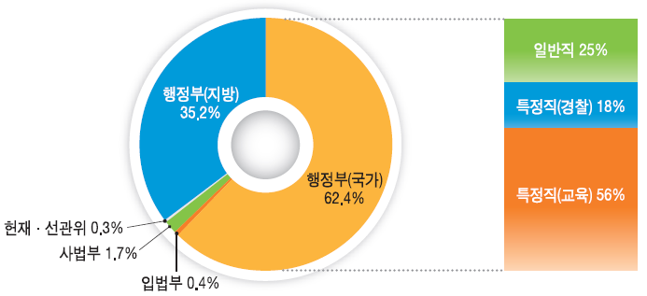
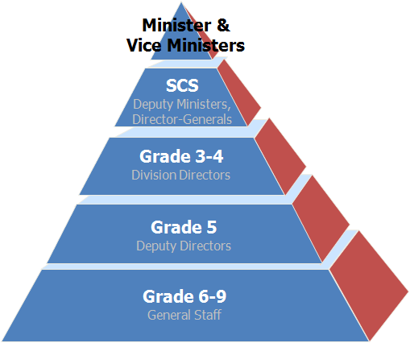

□ Upon the 2015 pension reform, the contribution rates of 14% will be increased to 18%, while the new accrual rates of pension will be decreased from the current 1.9% to 1.7% gradually
○ The retirement age will be raised up to the age of 65, which makes the amount of contribution higher but that of pension benefits lower
(in ten thousand won)
 |  | before (a) | after (b) | (b-a)/a
recruited by the 9th grade  → retired by the 6th grade | The amount of contributions | 42 | 54 | +28%
recruited by the 9th grade  → retired by the 6th grade | The amount of Pension benefits | 137 | 134 | -2%
recruited by the 7th grade  → retired by the 4th grade | The amount of contributions | 53 | 68 | +28%
recruited by the 7th grade  → retired by the 4th grade | The amount of Pension benefits | 173 | 157 | -9%
recruited by the 5th grade  → retired by the 2nd grade | The amount of contributions | 63 | 80 | +27%
recruited by the 5th grade  → retired by the 2nd grade | The amount of Pension benefits | 205 | 177 | -14%

5. How is the management of the Civil Service Pension Fund?

□ The Civil Service Pension Fund (CSPF) has been operating by the Civil Service Pension Service (CSPS) established in 1982, which are strictly supervised or inspected by the National Assembly, the Board of Audit and Inspection, accounting firms and the Government.
○ The amount of the CSPF is currently 8.5 trillion won (around 8.5 billion dollars) in total, of which the real financial assets make up 3.9 trillion won (around 3.9 billion dollars) except for the values of the resort facilities and housing leasing for civil servants.

□ The Korean Civil Service Pension Scheme is financed by a pay-as-you-go plan so that the annual pension expenditures are mainly financed by the revenues from the contributions of both civil servants and the government.
○ The role of the CSPF is mainly to keep reserve requirements or a contingency fund for the purpose of averting temporary liquidity risks because a 3.9 trillion won of the financial assets equals to just the amount of 5 months’ pension expenditures which reaches up to 10.2 trillion won yearly.

□ Currently, the rate of return on the CSPF investment is equal to 3.8 % during the last 5 years, the half of which is to be spent for annual pension expenditures to ease the financial strain while the other half is deposited to the Fund.

